APPLICATION FORM

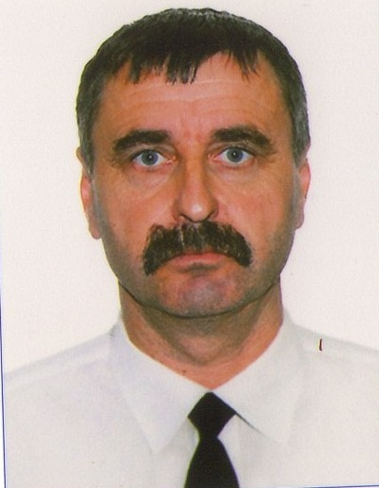

## 

|  |
| --- |
| **motorman** |

|  |  |  |  |  |  |  |  |  |  |  |  |  |  |
| --- | --- | --- | --- | --- | --- | --- | --- | --- | --- | --- | --- | --- | --- |
| Last name: | | | | Tiron | | | | | | Rank: | **motorman** | | |
| First name: | | | | Oleksandr | | | | | |  |  | | |
| Date of birth | | | | | Place of birth | | | | Citizenship | Marital status: | maried | | |
| 21.11.1963 | | | | | Ukraine | | | | Ukraine | Next of kin: | **Wife, Lidia Kirsanovna** | | |
| **Address**: | | | Odessa reg. Izmail ,vil.Larzhanka, str Kotovskogo 27 | | | | | | | Address: **Mobile:** | Odessa reg. Izmail ,vil.Larzhanka, str Kotovskogo 27 | | |
| Mob: | **+380975246140** | | | | | | **+3804841 4-72-76** | | |
| E-Mail: aleksandr.tiron63@mail.ru | | | | | | | | | | Height (sm.): | 187 | Overalls: | 52 |
| Eyes: | | grey | | | | Hair: | | brown | | Weight (kg.): | 82 | Shoes: | 43 |

## MARITIME EDUCATION

|  |  |  |
| --- | --- | --- |
| **Establishment /Name of institution** | **Qualifications** | **Date of attended** |
| Izmail colege № 9 | Motorman-seaman 1st class | 25.07.2003 |

## PERSONAL DOCUMENTS

|  |  |  |  |  |
| --- | --- | --- | --- | --- |
| **Description** | **Number** | **Issued** | **Expired** | **Place of issue** |
| Tourist Passport | EA794231 | 21.03.2008 | 21.03.2018 | Izmail |
| Seaman’s Identification Card | AB466152 | 13.10.2011 | 13.10.2016 | Izmail |
| US C1/D VISA | No |  |  |  |

PROFESSIONAL QUALIFICATION / CERTIFICATE OF COMPETENCY

|  |  |  |  |  |
| --- | --- | --- | --- | --- |
| **Certificate Name** | **Number** | **Issued** | **Expired** | **Place of issue** |
| Certificate of Competency **seaman** | 01493/2006/03 | 28.11.2006 |  | Izmail |
| Endorsement to certificate | 01493/2006/03 | 29.09.2011 | 02.09.2016 | Izmail |
| Certificate of Competency **motorman** | 00113/2007/08 | 28.03.2007 |  | Izmail |
| Endorsement to certificate | 00113/2007/08 | 29.09.2011 | 02.09.2016 | Izmail |

MARINE COURSES

|  |  |  |  |  |
| --- | --- | --- | --- | --- |
| Description | **Number** | **Issued** | **Expired** | **Place of issue** |
| STCW 78/95 A-VI/1(basic safety) | 114295U | 06.09.2011 | 06.09.2016 | Izmail |
| STCW 78/95 A-VI/2(survival craft) | 115483U | 02.09.2011 | 02.09.2016 | Izmail |

**SEA SERVICES (last five years)**

|  |  |  |  |  |  |  |  |
| --- | --- | --- | --- | --- | --- | --- | --- |
| **Vessel’s**  **name** | **Rank** | **Type** | **DWT** | **HP** | **From** | **To** | **Company name** |
| Aleksandr Arzhavkin | motorman | Dry cargo | 2060 | 1950 | 09.06.2008 | 26.11.2008 | MTC UKR |
| Venedikt Andreev | motorman | Refer. | 2099 | 1950 | 25.03.2009 | 12.09.2009 | MTC UKR |
| Aleksandr Arzhavkin | motorman | Dry cargo | 2060 | 1950 | 02.05.2010 | 18.06.2010 | MTC UKR |
|  |  |  |  |  |  |  |  |
|  |  |  |  |  |  |  |  |
|  |  |  |  |  |  |  |  |